**Pre-building Plan:**

**Choice of Language:**

I will code my implementation in Java. The reasons for this are that despite Python being favoured in building neural networks, due to the wealth of libraries for the language specifically for neural works, for the purposes of this course I wish to reduce reliance in pre-built libraries wherever possible so as to understand the details of how the algorithms work themselves. In addition, I believe an object-oriented approach will be well suited to this project. Having a MLP class with neurons as attributes and algorithms like backpropagation and activation functions as methods of that class seems to me to be a natural fit for this problem. Finally, I will be coding in Java for my upcoming placement, so improving my proficiency in the language is beneficial.

I will code my data cleaning software in Python, as the language has the support of many libraries built for data analysis and management that will make the process as frictionless as it can be. I will be using the Pandas library, as it has support for Excel sheets, allowing me to read and write directly to the .xlsx file.

**Cleaning the Data:**

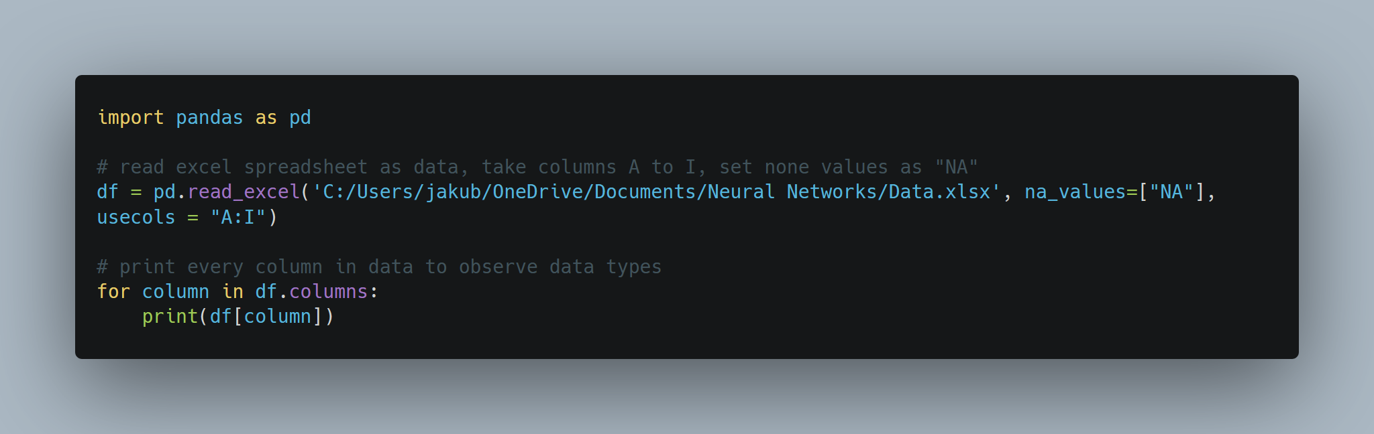I will duplicate the Excel spreadsheet into two files, “Data.xlsx” and “Data Backup.xlsx”. The latter contains the original data that will not be modified in case an error is made in cleaning the data I have a backup I can revert to. The former will be the file that will be read from and written to the clean the data. I also will use a text file “Bin.txt” that will contain all modifications of data so we can obverse the changes.

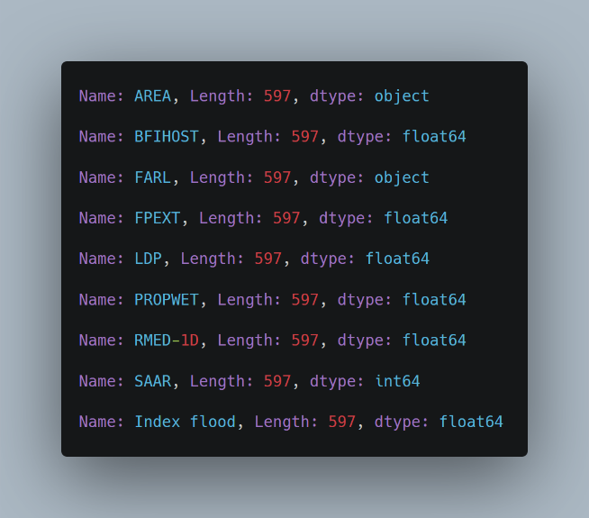Observe that the data type for AREA and FARL are “object” instead of “float 64”. This introduces the possibility for letters and other non-numeric values to be within those columns. Therefore we must check and remove those characters from the values in those two columns.

Therefore, we write a try, except block to catch any items that cannot be parsed into a floating point.

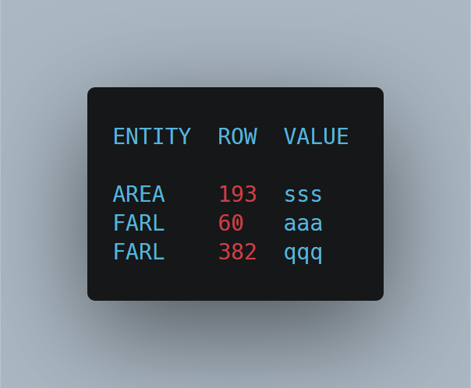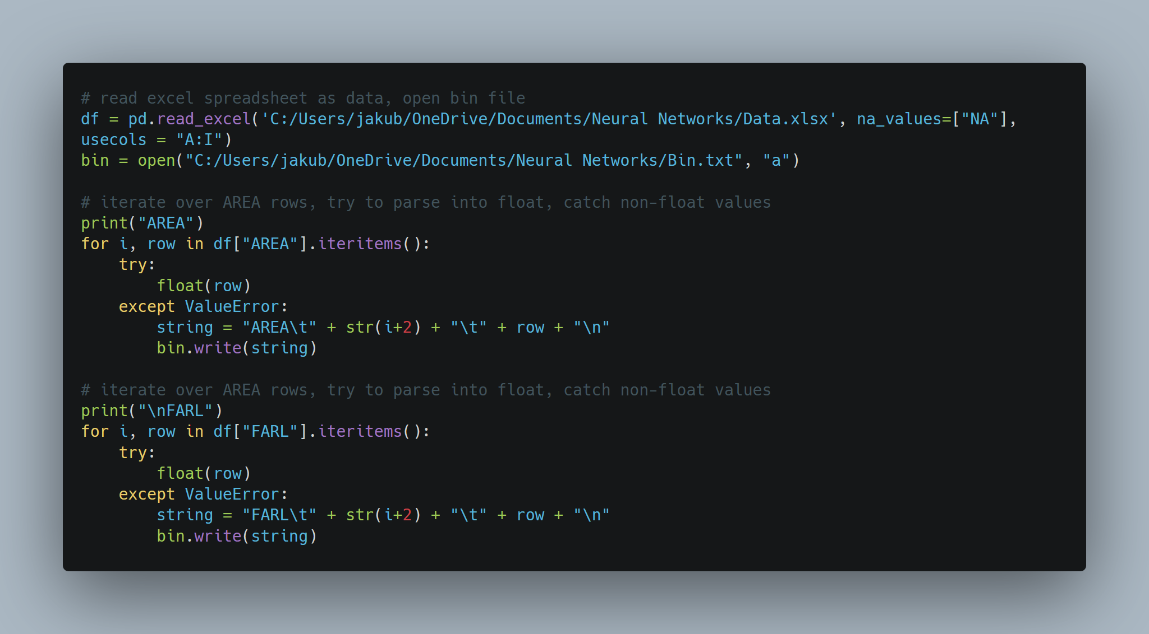Result:

Now that we have found all values that are non-numeric and therefore clearly invalid, we simply delete these rows from our data, as there are plenty of other datapoints, and hence interpolating to try and predict what the correct was would yield little difference for a lot of effort. I built and ran code to remove these rows, then verified in the data that the deletion was correct.

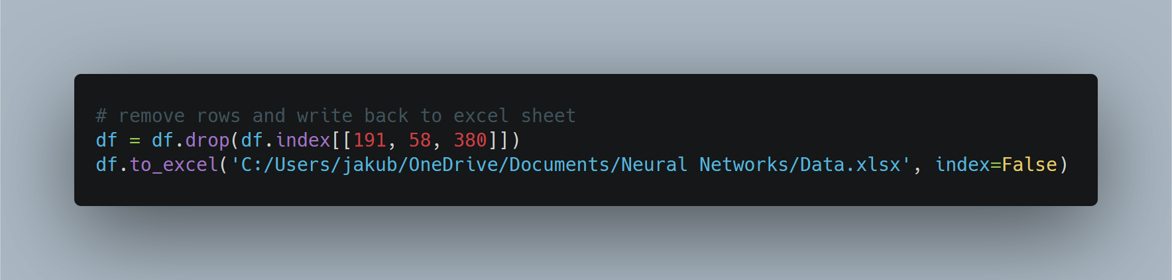

It remains to perform validation on all the other values.

|  |  |  |  |
| --- | --- | --- | --- |
| Attribute | Minimum Value | Maximum Value | Justification |
| AREA | 0.00 | N/A | Area cannot be negative |
| BFIHOST | 0.00 | 1.00 | Ratio values |
| FARL | 0.00 | 1.00 | Ratio values |
| FPEXT | 0.00 | 1.00 | Ratio values |
| LDP | 0.00 | N/A | Distances cannot be negative |
| PROPWET | 0.00 | 1.00 | Ratio values |
| RMED-1D | 0.00 | 340 | Most rainfall in 24 hours (UK) |
| SAAR | 0.00 | N/A | Rainfall cannot be negative |
| Index Flood | 0.00 | N/A | Value cannot be negative |

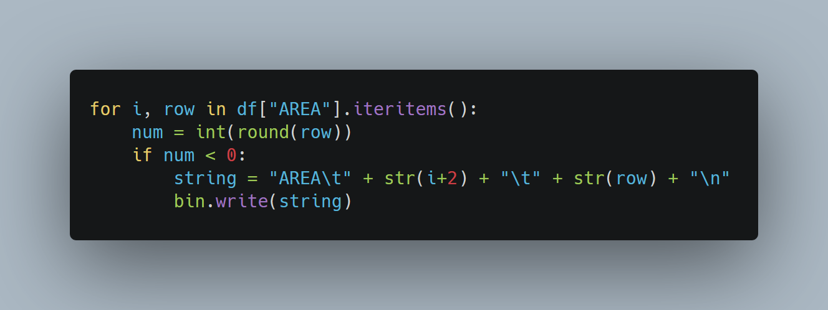Here is an example of how I handle validation of columns (AREA in this example. We check each row value against some condition and write to “Bin.txt” if its met.

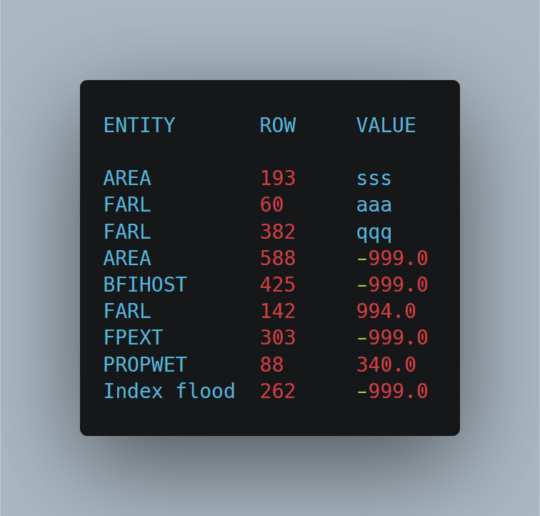

This is the final state of the “Bin.txt” file. It contains all values that are clearly not numeric as per previous examples, and every numerical value that is clearly of range. Deletion is simple, as per the previous example also. Take not however that previous deletion has changed the row numbers for some of these data points, and therefore would be different to the original data.

In the interest of avoiding hard coding my solution I have automated the cleaning process by introducing validation functions and looping over each column, applying the appropriate function to each column, and dropping rows that fail the validation process.

**Standardising and Segmenting the Data:**

It then remains to segment data in three subsets: a training subset, a validation subset and testing subset. In order to avoid any seasonal biases that obviously have an impact on rainfall levels, the data should be randomly segmented. However, the catchment data is not sequenced by date, and hence is already random. Therefore, we simply segment the first 60% for training, a subsequent 20% on validation and final 20% on testing.

I will standardise and revert the data with their respective formulae:

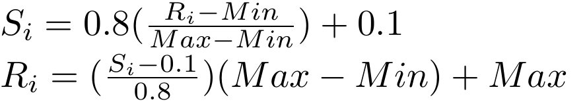

These formulae can be used on the data by writing functions that compute Si and Ri values for each row. Then we can iterate over each column and apply the function to fully standardise or revert the data:

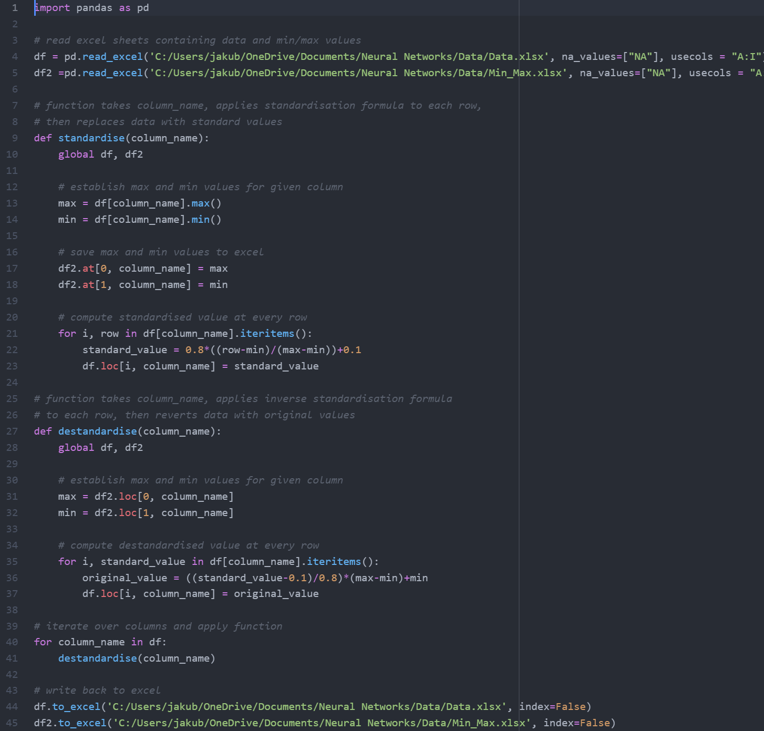

Here we can observe a sample of the difference between standardised and original data:

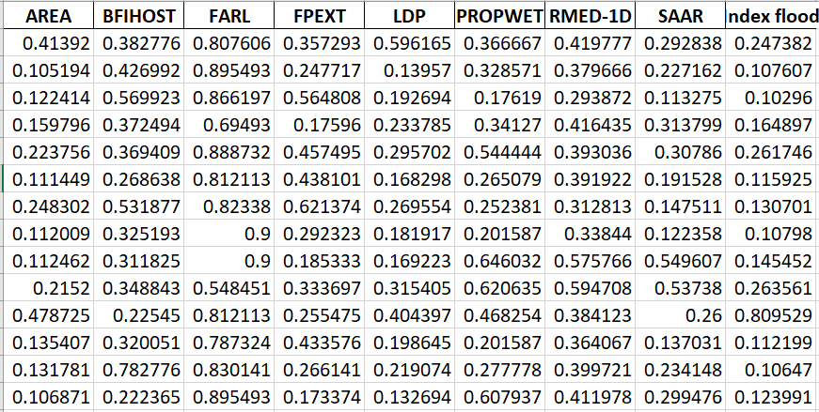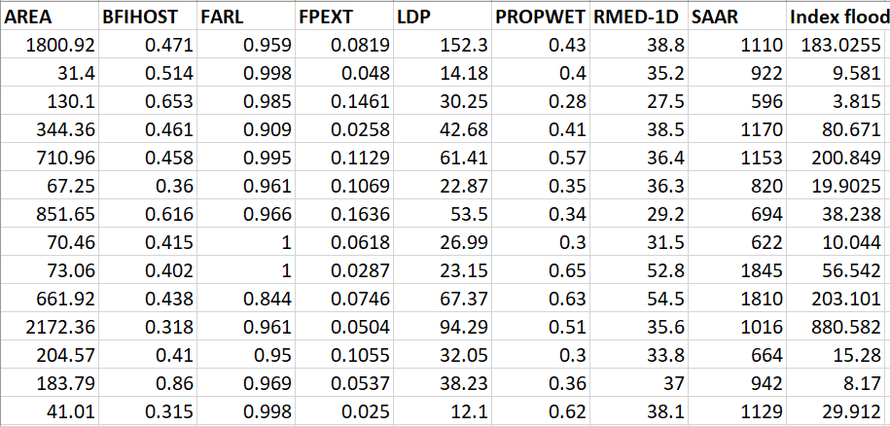

**Constructing the Artificial Neural Network:**

**Number of Hidden Nodes:**

We can see from the dataset that we have 8 predictors and one single predictand. Therefore, we know that our Neural Network will contain 8 input nodes, and one output node. By suggestion in the lecture videos, I will only construct a single hidden layer, since it has been said in those videos that for simple problems, i.e., problems with a single predictand, a single hidden layer is said to be sufficient.

It is claimed in the lecture slides and videos that:

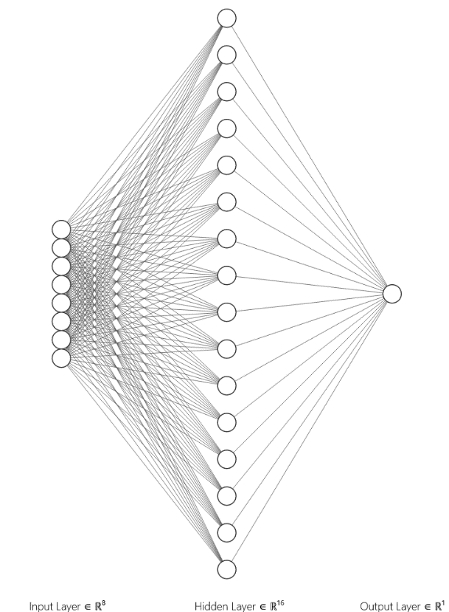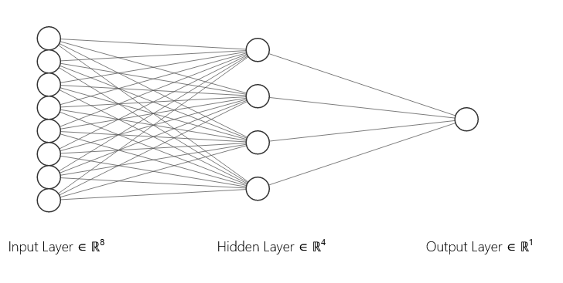Therefore, the number of hidden nodes in our Neural Network will range from 4 to 16 hidden nodes, with the final number depending on whichever network performs the best on our validation set, i.e., what number produces the smallest error.

Here is just a simple comparison of the two extremes in the range of possible hidden nodes. We can see that the number of weights and biases and hence the dimension of the search-space will vary significantly across the different networks.

|  |  |  |
| --- | --- | --- |
| Parameters | 4 Hidden Node Network | 16 Hidden Node Network |
| Hidden Node Biases | 4 | 16 |
| Hidden Node Weights | 8x4 = 32 | 8x16 = 128 |
| Output Node Biases | 1 | 1 |
| Output Node Weights | 4 | 16 |
| Total Parameters | 41 | 161 |
| Global Minima | 4! x 24 = 384 | 16! x 216 = 1018 |



For the sake of simplicity and ease of testing, I will generate a random set of 161 numbers within that range, then each multi-layer perceptron will take its initial weights and biases from this pool. The code for this is trivial when using Pandas for Python:

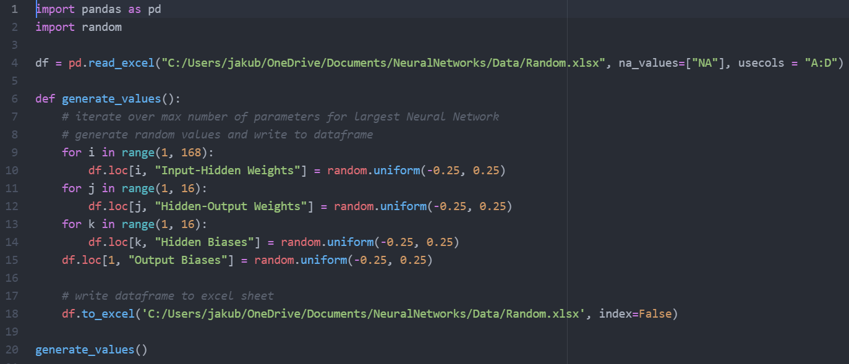

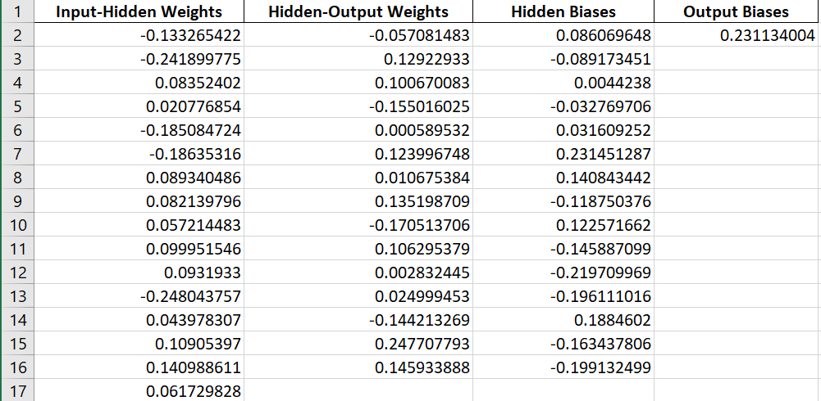

**Coding the Multi-Layer Perceptron:**

To code the Neural Network, I will construct a MLP class with multi-dimensional arrays to store weights, biases and outputs of neurons, and methods to initialise and modify those weights and biases accordingly. The three key arrays we will use are:

* Double outputs[layer][neuron]
* Double biases[layer][neuron]
* Double weights[layer][neuron][prevNeuron]



B1, O1

B2, O2

W1

W2

For examples on how outputs, biases are accessed for the example on the left:

B1 = biases[1][0], B2 = biases[2][0]

O1 = outputs[1][0], O2 = outputs[2][0]

W1 = weights[1][0][0], W2 = weights[0,3,7]

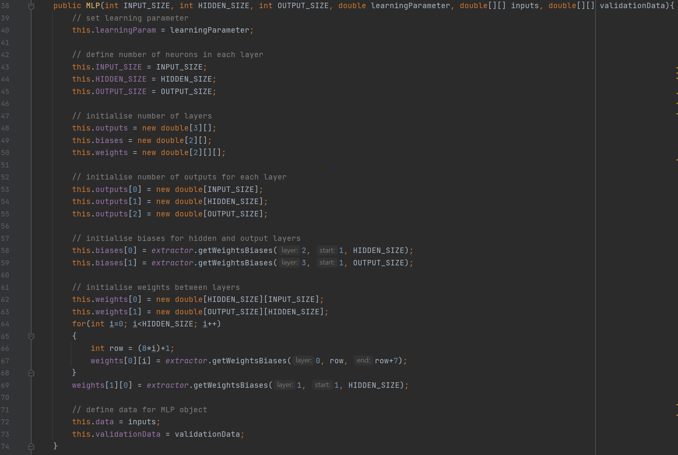Below is the constructor for the MLP class. As you can see the primary purpose of the constructor is the initialise the various arrays with appropriate sizes for each layer. The sizes themselves are determined by the number of input nodes, hidden nodes, and output nodes, which are taken as inputs for the construction of the MLP object. Weights and biases are taken from the excel file containing initial values using a rudimentary class called Extractor that reads the Excel file.

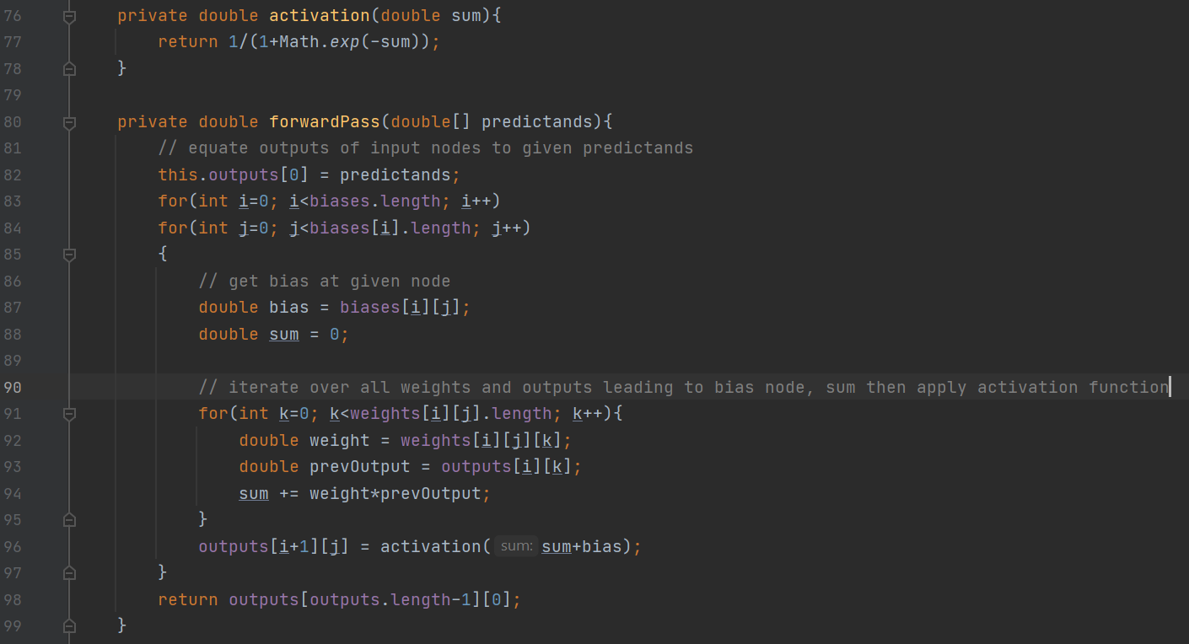The next step is to code the algorithm computing the forward pass. Fundamentally, this algorithm is a process of taking a sequence of predictands, setting the first layer of outputs to the predictands (inputs for the forward pass can be taken as outputs of the first layer of nodes.). We then take a node, get the bias from that node, then get the sum of products of weights and outputs leading to that node. Add the bias to that sum, then apply the activation function. Take that as the output for that node and repeat the process.

Now this algorithm functions for a single output node at the moment, which is somewhat problematic as the MLP class is supposed to take any arbitrary amount of input, hidden and outputs nodes. However, for the purpose of this problem, the algorithm will suffice, so I will not be making the necessary modifications.

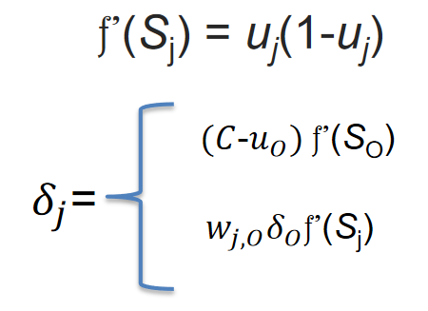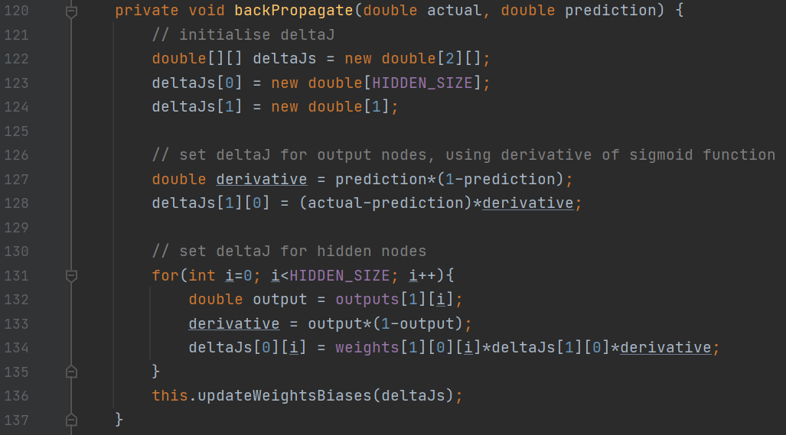After the forward pass, we obtain the prediction from the network. In order to backpropagate, we need to set the necessary δJ’s at output and hidden nodes. Since we are using the sigmoid activation, the derivative and δJ’s are as follows (taken from slides):

The algorithm takes the predicted value derived from the forward pass algorithm, compares it with the actual value, and computes the δJ’s accordingly. You may note that once again this algorithm is dependant on there being a single output node and a single hidden layer, as the δJ for hidden nodes are dependent on deltaJs[1][0] which is the δJ for the output node. Once again, it suffices for the problem we have, and hence I will keep it in its current state.

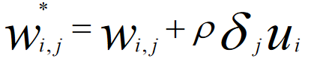After computation of δJ’s has been completed for all hidden and output nodes, it remains to adjust all the weights and biases according to those δJ’s. This is done accordingly to the following formula in the slides:

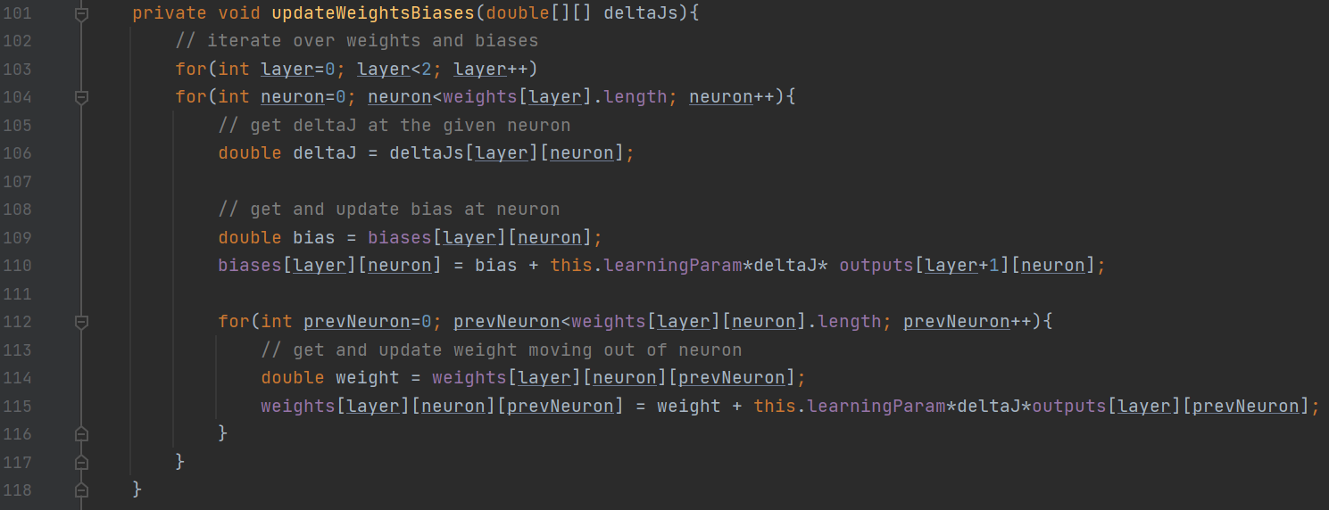Where Wi,j* is the new weight/ bias, Wi,j is the current weight/bias, ρ is the learning parameter, Ui is the output out of that node.

We have everything required to run an epoch of the MLP. Therefore, I will construct a public method, called runNetwork(), that takes a given number of epochs as input, and calls the functions previously defined iteratively, storing errors for the training and validation sets.

**Analysis of the Base Algorithm:**

Now we have everything required in order to construct multiple MLP’s, of varying number of hidden nodes, and decide on which is the most optimal. To do this I will write the validation errors into excel and plot them in a log-log scale. I will use a log-log scale to space out the lines in the graphs to allow for clearer analysis.

It is immediately clear that the number of hidden nodes does not play any major role in the error function generated from the validation data. However, we still need to decide which is the most optimal, and since there are no clear differences in the graphs, even with a log-log plot, I will simply select the number of nodes that produces the smallest error at any epoch.

This will also show us how many epochs to run for the base algorithm to avoid over-fitting.

We can see that this graph is far more informative than the previous. It is clear here that the number of hidden nodes that produces the lowest error is 14.

Next, I select the error column produced by a neural network with 14 hidden and use a simple Excel formula to locate the row and hence epoch that produces this lowest error. The result I get is that training the network for 30,000 epoch produces the lowest error.

I have plotted the network with 14 hidden nodes, with a log10 y-axis and log13.2 x-axis to further illustrate the fact that the lowest error is produced at roughly 30,000 training epochs.

Now that we have located the most optimal network configuration for the base algorithm with no improvements, we should analyse the predictions made by this network for the testing dataset and compare it to the actual values. This way we can get a rough idea of how well the network actually performs in a real-world scenario.

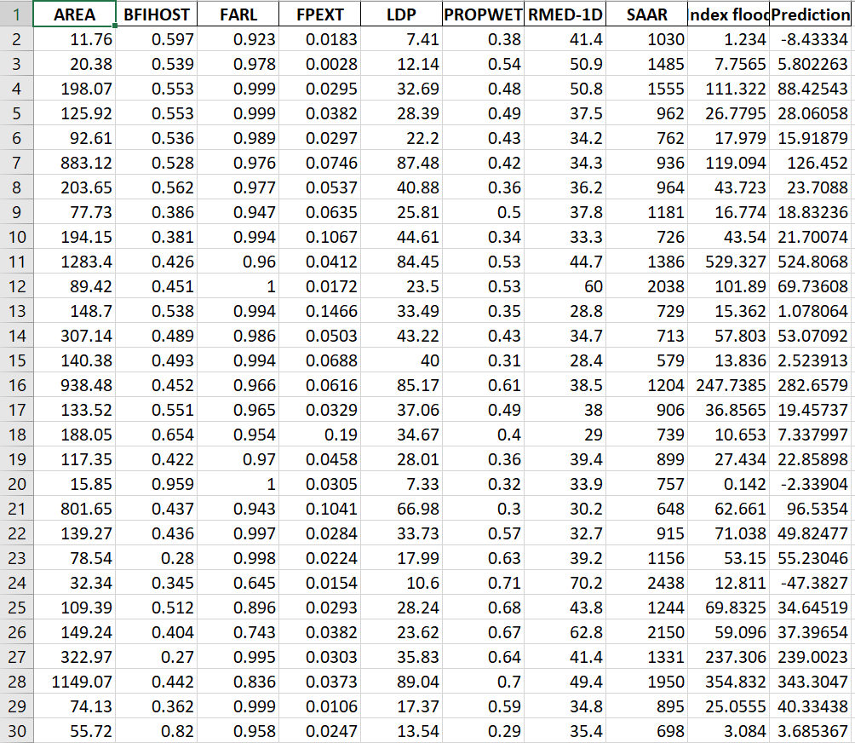

Here we can observe the predictions made by the current best configuration of the network. All values have been de-standardised for clarity. My judgement thus far is that the predictions are mostly quite sensible with the exception of negative values, which will be handled later. The network seems to perform best when the prediction is large, and worse with small values. That said, there is obviously a lot of room for improvement, which is expected of the base algorithm.

The first improvement we will look at is momentum, so that we can converge to an optimal solution is a smaller number of epochs, or even find new minima (when max epochs are equated).

**Implementation of Momentum Improvement:**

Momentum is an easy improvement to implement as it only involves adding an additional term to the algorithm that adjusts weights and biases at given node. This term is the product of an α co-efficient, which I will set to 0.9 according to the lecture slides, and the difference between the new weight/ bias and old weight/ bias. The formula is below:

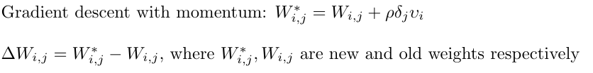

The code for this is rudimentary, it only involves storing changes in weights and biases and adding the term, provided momentum is set to true. Now let us observe the difference in error function for momentum and the base algorithm at our current configuration:

Observe that not only do we converge to an optimal solution with less epochs than the base algorithm, but we also have a smaller overall error across all epochs. This is a clear and measured improvement to our neural network. Therefore, all subsequent networks will have momentum activated by default.

Now let us analyse the momentum graph more closely.

Observe that the number of epochs required to find out minima is roughly 5000, which means that our algorithm found the most optimal solution with 500% less epochs!

That said, out minimal error has not decreased by any substantial margin, and hence this model is not likely to present any major improvement when tested against our test dataset.

We must therefore continue adding improvements.

**Implementation of the Bold Driver Improvement:**

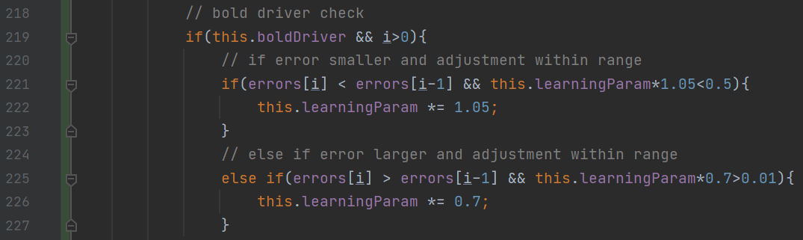To implement bold driver, we simply need to check the errors array after very epoch, check if it has increased or decreased then apply a multiplier, so long as it stays within the range of [0.01, 0.5] mentioned in the lecture notes. The code required to do this is once more rudimentary, but I will showcase it regardless:

Note that here we are comparing values in the training error function, not the validation error function. I will also try using the validation error function as a comparitor, and decide on which produces the most favorable results, i.e. finds the smaller minima.